**SmartBridge Virtual Internship – Ideation Phase**

**Project Title**: Visualizing Housing Market Trends – An Analysis of Sale Prices and Features  
**Team Member**: CHEREDDY VENKATA VINOD KUMAR REDDY  
**Date**: 29/06/2025

**1. Problem Statement**

The real estate market produces vast amounts of complex data, making it difficult for buyers, sellers, and investors to draw actionable insights. Without visualization, it's challenging to understand how factors like renovation status, house age, and structure affect property sale prices.

### ****Project Context****

The housing market is shaped by various attributes like renovation status, structural features, house age, and overall conditions. While this information is embedded in large datasets, end users (buyers, investors, agents) struggle to extract insights due to lack of interactive tools. This project aims to create an accessible, web-embedded Tableau dashboard to visualize these trends effectively.

| **Problem Statement ID** | **I am (Customer)** | **I’m trying to** | **But because** | **Which makes me feel** |
| --- | --- | --- | --- | --- |
| PS-1 | A first-time homebuyer | Find a house within my budget that meets my preferences | Housing data is confusing and lacks user-friendly visual insights | Lost, overwhelmed, and hesitant to decide |
| PS-2 | A real estate investor | Identify properties with high return based on trends | There is no visual tool to explore sale price patterns and renovation impacts | Frustrated, unsure about investment potential |
| PS-3 | A real estate agent | Provide quick recommendations using recent sales trends | Data is spread across CSVs or static reports with no interactivity | Less efficient, unable to deliver fast, clear advice |

This version reflects:

* The **goal of simplifying housing data** via **Tableau**.
* Embedding that dashboard into a **Flask web interface**.
* Real user types like homebuyers, investors, and agents.
* The emotional impact of not having accessible insights.

**2. Empathy Map Canvas**

* **Thinks**: Getting best value and making data-driven decisions
* **Feels**: Overwhelmed by raw data and lack of tools
* **Says**: Want simple, interactive platforms for insights
* **Does**: Compares listings manually or relies on agents

**Empathy Map Canvas:**

An empathy map is a simple, easy-to-digest visual that captures knowledge about a user’s behaviours and attitudes. It is a useful tool to helpsteams better understand their users. Creating an effective solution requires understanding the true problem and the person who is experiencing it. The exercise of creating the map helps participants consider things from the user’s perspective along with his or her goals and challenges.

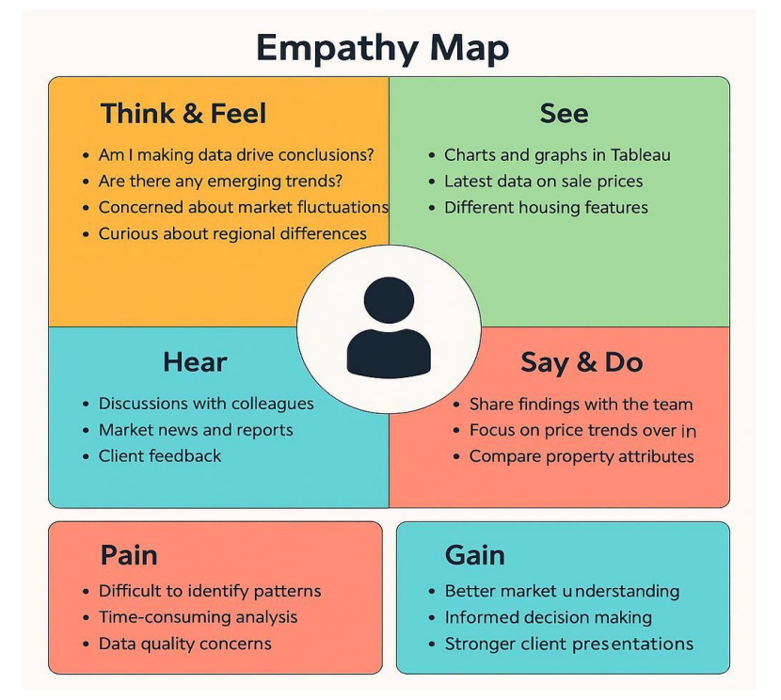

**3. User Needs & Goals**

* Understand how renovation and house age affect price
* View KPIs for housing data
* Prefer visual dashboards over raw tables
* Access the tool via browser without installing software

**4. Brainstorming**

* Dashboards for sale price trends
* Visuals for structure vs price
* Storyboards for insight progression
* Flask web app for interface and navigation

Brainstorm & Idea Prioritization Template: Brainstorming provides a free and open environment that encourages everyone within a team to participate in the creative thinking process that leads to problem solving. Prioritizing volume over value, out-of-the-box ideas are welcome and built upon, and all participants are encouraged to collaborate, helping each other develop a rich amount of creative solutions. Use this template in your own brainstorming sessions so your team can unleash their imagination and start shaping concepts even if you're not sitting in the same room.

Reference: <https://www.mural.co/templates/brainstorm-and-idea-prioritization>